Queensland Government

RACF Planning and Response Checklist

Business Continuity or Disaster / Emergency Events – July 2023

The intention of this Actions Flowchart and the following Checklist is to support Residential Aged Care Facility (RACF) providers with planning for and undertaking response actions when there is notification of an emerging or actual hazard/disaster/ emergency event, or a disruption that requires a business continuity response has occurred.

This Checklist is supported by the ***RACF – Planning Resource – Business Continuity and Disaster/Emergency Management***(the *Planning Resource*). Each action corresponds to a section of the *Planning Resource*.

#### This document has the following sections:

* Actions Flowchart
* Response Checklist
  + Determine Shelter in Place or Evacuation
* Recovery and Review Checklist
* Planning Checklist

#### Steps to using this Checklist

1. Use the *Planning Resource*, alongside this checklist, to develop Business Continuity and Disaster/Emergency Management Plans for your facility.
2. Complete the fillable sections of the Checklist to contextualise the checklist for your facility.
   1. Checklist Action – Use the prompts to fill in where documents are kept and key contacts.
   2. Assign the role to a person who is responsible for completing the action in an event.
3. Add or remove steps as is appropriate for your facility.

#### Example – Completed Checklist

|  |  |  |  |  |  |
| --- | --- | --- | --- | --- | --- |
|  | Checklist Action | Planning Resource Section | Role / Person Responsible | Action Notes / Comments | Completed by |
|  | Review and update your Facility Profile.  **Our profile is kept:**  *Printed and attached to this checklist (last printed on 01.02.2023). On the G:Drive – Emergency Management* | Section 4.1 | *Emergency Coordinator / Nurse in Charge of shift* | *Example only* |  |
|  | Contact your Local Council / Local Disaster Management Group (LDMG) to understand planning/response activities.  **Our contacts are:**  *Jane Doe – Disaster Coordinator, Local Council,  Contact Details* | Section 2.2 | *Emergency Coordinator / Nurse in Charge of shift* | *Example only* |  |

## Disaster and Emergency Response Actions Flowchart

The below flowchart, and checklist on the following pages, provides an example of actions that may need to occur upon identification of a disaster or emergency incident. Depending on the event, these actions may not occur in a linear fashion, or in urgent situations where adhering to the complete list of actions may not be possible, some

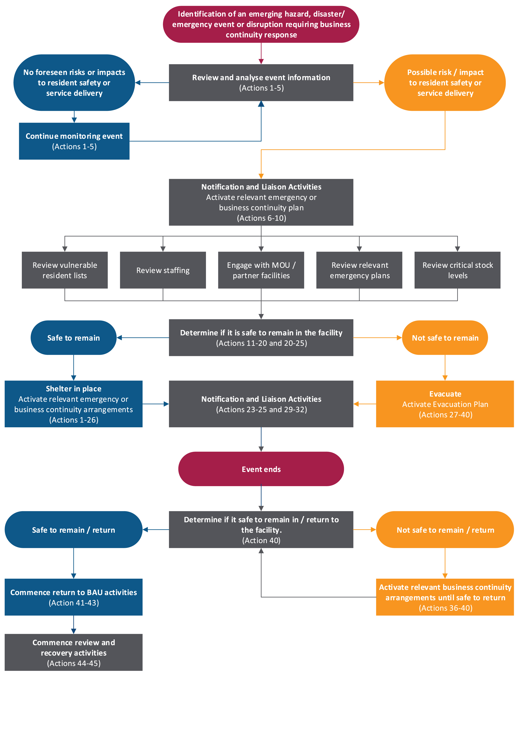

## Disaster and Emergency Response Actions Checklist

|  |  |  |  |  |  |
| --- | --- | --- | --- | --- | --- |
| # | Checklist Action | Planning Resource Section | Role / Person Responsible | Action Notes / Comments | Completed by |
| 1 | Any staff member who identifies a potential disaster or emergency incident should escalate to the person in-charge at the facility on that day. |  |  |  |  |
|  | **Review and analyse event information – on identification of potential incident** | | | | |
| 2 | Review the local Disaster Dashboard/council website for event information. Sign up for alerts if available.  [Local government disaster dashboards | Community support | Queensland Government (www.qld.gov.au)](https://www.qld.gov.au/community/disasters-emergencies/disasters/resources-translations/local-government-disaster-dashboards) | Section 3.2 |  |  |  |
| 3 | Review and update your Facility Profile.  **Our profile is kept:** *[insert details of where users can find the completed Facility Profile]* | Section 4.1 |  |  |  |
| 4 | Refresh yourself and relevant team members with the facility disaster / emergency plans.  **Our plans are kept:** *[insert details of where users can find the organisation’s disaster / emergency plans. Note: it is advisable to have both electronic and hard copy locations noted as power outages may preclude use of IT services]* | Section 4 |  |  |  |
| 5 | Ensure relevant staff are aware of their roles and responsibilities during an event. | Section 4.2 |  |  |  |
|  | **Notification and Liaison Activities – before/during incident impacts** | | | | |
| 6 | Commence an incident log to record actions and decisions. | Section 4 |  |  |  |
| 7 | Notify the facility managers / owners about the event.  **Our facility managers / owners contact details are:**  *[Insert contact details, or where to find these]* | Section 4.4 |  |  |  |
| 8 | Activate your local incident management system and response team.  **Our plan is kept:** *[insert details of where users can find the organisation’s Facility disaster / emergency plans]* | Section 4.2 |  |  |  |
| 9 | Contact your allocated Local Disaster Management Group (LDMG) representative to understand planning/response activities.  **Our contact for the LDMG is:** [*Insert contact details including name / role, phone number and email address]* | Section 2.2 |  |  |  |
| 10 | Inform staff, residents and next of kin of the event. Continue to keep them updated.  **Our communications plan is kept:** *[insert details of where users can find your organisation’s communications plan]* | Section 4.4 |  |  |  |
| 11 | Review and update the list of pre-identified high-risk residents and residents considered suitable for potential voluntary early evacuation to ensure current. Ensure that any residents currently off-site (e.g., in hospital) are noted to not be on-site. Continue to update the list each shift. | Section 6 |  |  |  |
|  | **Decision Making and Response Actions – before/during incident impacts** | | | | |
| 12 | Assess potential (or actual) service disruptions (e.g., to power, water, supply chain etc.) and plan / respond accordingly (e.g., acquiring a back-up generator, fuel, bottled water etc.) | Section 5 |  |  |  |
| 13 | Continue to gather intelligence to inform planning and decision-making (e.g., from the Bureau of Meteorology, Council’s Disaster Dashboard etc.). | Section 3.2 |  |  |  |
| 14 | Consider if it is safe to remain in the facility or if evacuation may be required **(****see next section****).** | Section 6 |  |  |  |
| 15 | Confirm pre-identified high-risk residents and determine if they should be evacuated pre-emptively. Apply resident identification wrist bands to all residents with identifying information and photo.  **Our list of residents and their requirements is kept:** *[insert location of current high-risk resident list and their requirements]* | Section 4.1 |  |  |  |
| 16 | Determine Shelter in Place (if it is safer to remain in the facility) or if Evacuation to a safer location is required. **(see Actions 20-37 in next section).** | Section 6 |  |  |  |
| 17 | Confirm availability of required transport and services and activate plans with these providers.  **Our transport provider contacts are:** [*insert contact details of transport providers***]** | Section 4.6 |  |  |  |
| 18 | Review staffing plan for the next three (3) days, at a minimum. Consider if:   * Evacuation is required * Facility becomes isolated * Staff isolated in the facility * Staff can’t access facility | Section 5.1 |  |  |  |
| 19 | Engage with partner facilities or facilities where a Memorandum of Understanding (MOU) exists. Determine:   * If this event impacts their facilities * If they can honour agreements * If they will require support.   **Our contacts are:** *[insert contact details of MOU providers]* | Section 4.7 |  |  |  |
| 20 | Review critical stock levels. Consider scenarios such as:   * an evacuation is required; or * the facility becomes isolated and may not be able to receive stock for a period of time.   Make plans to maintain or conserve supply.  **Our stock list and supply plans are kept:** *[insert details of where the organisation’s plan is kept]* | Section 5.7 |  |  |  |
| 21 | Activate event-related financial arrangements. | Section 4.5 |  |  |  |
| 22 | Commence recovery planning, including return to BAU activities when the event ends. | Section 7.1 |  |  |  |

### Determine Shelter in Place or Evacuation

Depending on the event, it may be safer for residents to remain in the facility, or it may be necessary to evacuate to an alternative, safer location.

Dynamic assessment of the situation should occur, and any decision to evacuate should be made as early as possible, taking into consideration the lead time to arrange commercial and/or private transportation and alternative locations for residents.

A decision to evacuate should be made by the facility Emergency Management Team in conjunction with facility owners / managers and local authorities such as Queensland Police Service (QPS) and Queensland Fire and Emergency Services (QFES) etc.

During an event, and where evacuation has been determined as the most appropriate action, Emergency services may need to set up a temporary forward command post at the facility. The facility will need to have suitably qualified persons available to meet emergency services and provide assistance i.e., maps, communication channels, knowledge of the facility and residents etc.

|  |  |  |  |  |  |
| --- | --- | --- | --- | --- | --- |
| # | Checklist Action | Planning Resource Section | Role / Person Responsible | Action Notes / Comments | Completed by |
|  | **Determine if it is safe to remain in the facility** | | | | |
| 23 | Assess if the facility safe to remain in? | Section 6.1 |  | **Yes / No** |  |
| 24 | Ensure that facility owners / management (where feasible) and your organisation’s Emergency Response Team are involved in the decision to stay/evacuate.  **Facility owners / management contact details are:** *[Insert name and contact details of facility owners / managers]* | Section 6.5 |  |  |  |
| 25 | Consider residents who may require or prefer early / voluntary evacuation. Work with next of kin and relevant evacuation locations to enact this.  **Our list of residents and their requirements is kept:** *[insert location of resident list]* | Section 6.1 |  |  |  |
|  | **Safe to remain / Shelter in Place** | | | | |
| 26 | Staff, residents and next of kin are notified of the event and potential outcomes. They continue to be informed throughout the event.  **Our communications plan is kept*:***  *[insert location of communication plan]* | Section 4.4 |  |  |  |
|  | **Not safe to remain / Evacuation is necessary:** | | | | |
| 27 | Notify staff, residents and next of kin of the event and potential outcomes. Keep them informed throughout the event.  **Our communications plan is kept:** *[insert location of communications plan]* | Section 4.4 |  |  |  |
| 28 | Notify the Australian Government Department of Health and Aged Care on 1800 300 125, the Aged Care Quality and Safety Commission on 1800 951 822 and NDIS (if relevant) if there is a requirement to evacuate or service delivery has been impacted. | Section 4.4 |  |  |  |
| 29 | Evacuation locations and required resources are considered and planned. | Section 6.6 |  |  |  |
| 30 | Confirm pre-identified high-risk residents and determine their transport and care requirements.  **Our list of residents is kept:** *[insert location of resident list]* | Section 4.1 |  |  |  |
| 31 | Consider private transport arrangements required, document and arrange.  **Our private transport providers are:** [*insert contact details of transport providers*] | Section 4.6 |  |  |  |
| 32 | Engage with Queensland Ambulance Service (QAS) to understand capability to support planning and response.  **Our QAS contact is:** [*insert role and contact details*] | Section 4.6 |  |  |  |
| 33 | Engage with partner facilities or facilities where a Memorandum of Understanding (MOU) exists. Determine:   * If this event impacts their facilities * If they will be able to honour support agreements * If they require support themselves.   **Our contacts for partner facilities are:** *[insert contact details of MOU providers]* | Section 4.7 |  |  |  |
| 34 | Notify and liaise with your allocated LDMG contact and other key stakeholders and discuss requirements.  **Our contacts are:** *[insert contact details of LDMG contact]* | Section 2.2 |  |  |  |
| 35 | If support is required (beyond what can be arranged independently), and the LDMG is activated, liaise with your allocated LDMG contact to discuss submitting a request for assistance.  If the LDMG is not activated, contact directly the relevant emergency or health service that you require support from. | Section 4.8 |  |  |  |
| 36 | Ensure that each resident is clearly identified. For example:   * wristband * current photo with medical record   and is travelling with a “go bag” that includes:   * medication (with consideration for S8/S4 requirements, usual pharmaceutical supplier) * medical records (including myHealthRecord) * care plan * next of kin contact information * clothing * any required equipment (e.g., walker/wheelchair / CPAP / PEG feeds / continence aids etc.)   **The process for supporting evacuated residents is kept:** *[insert location of process for supporting evacuated residents]* | Section 6.6 |  |  |  |
| 37 | Maintain paper and digital records detailing where each resident is being evacuated to.  **Our tracking system is kept:** [*insert location of tracking system to record details of evacuated residents]* | Section 6.6 |  |  |  |
| 38 | Implement the care plan for each resident at the new location.  **The process for supporting evacuated residents is kept:** [*insert location of process for supporting evacuated residents]* | Section 6.6 |  |  |  |
| 39 | Commence recovery planning and early planning for the return of residents and update as the response continues.  **The process for returning residents is kept:** [*insert location of process]* | Section 6.8 |  |  |  |
|  | **After the event has passed** | | | | |
| 40 | Determine when/if it safe to return to/remain in the facility.  The decision to begin the return process should be made by the facility managers, in conjunction with the local disaster management group, emergency services and/or other authorities.  **The process for returning residents, including checklist of actions to ensure preparedness to deliver required services on return, is kept:** [*insert location of process]* | Section 6.8 |  |  |  |

## Recovery and Review Checklist

|  |  |  |  |  |  |
| --- | --- | --- | --- | --- | --- |
| # | Checklist Action | Planning Resource Section | Role / Person Responsible | Action Notes / Comments | Completed by |
|  | **Commence recovery and review activities** | | | | |
| 41 | Commence return to BAU activities. | Section 7.1 |  |  |  |
| 42 | Stand down the incident management system and response team. | Section 4.3 |  |  |  |
| 43 | Establish a recovery plan and timeline. | Section 7.1 |  |  |  |
| 44 | Conduct a post-event debrief. | Section 7.3 |  |  |  |
| 45 | Review and update plans with lessons identified from the response. | Section 7.3 |  |  |  |

## Planning Checklist

|  |  |  |  |
| --- | --- | --- | --- |
| Function | Planning Resource Section | Person / Role Responsible | Date last completed |
| Ensure a Business Impact Assessment (BIA) has been completed and is current. | Section 4 Section 5 Appendix 3 |  |  |
| Ensure facility business continuity, disaster/emergency, evacuation, and communication plans are developed and up to date. | Section 4 |  |  |
| Ensure plans have been shared with all staff and relevant stakeholders such as the Australian Government Department of Health and Aged Care, local council, LDMGs and local Hospital and Health Service (HHS). | Section 4.6 |  |  |
| Contact the disaster coordinator and your local council to determine how you will interact with the LDMG before, during and after a disaster/emergency. Determine who your allocated LDMG contact is. | Section 2.2 |  |  |
| Assign emergency roles to staff members with the appropriate delegations and authority. | Section 4.2 |  |  |
| Ensure staff have received training (and maintain up to date training) to be able to effectively carry out the plans. | Section 3.5 |  |  |
| Ensure the plans are exercised annually. | Section 3.4 |  |  |
| Maintain intimate knowledge of the facility, local geography, ingress and egress routes and location of emergency equipment and update new or changed information into the plans. | Section 4 |  |  |
| Maintain Facility profile, including Resident Profiles and ‘go bags’ / plans. | Section 4.1 Appendix 2 |  |  |
| Determine who chairs the Disaster/Emergency Planning Committee and ensures actions are implemented. | Section 3.3 |  |  |