THREAT IS REDUCED
[Location]
Severe Weather (Descriptor)
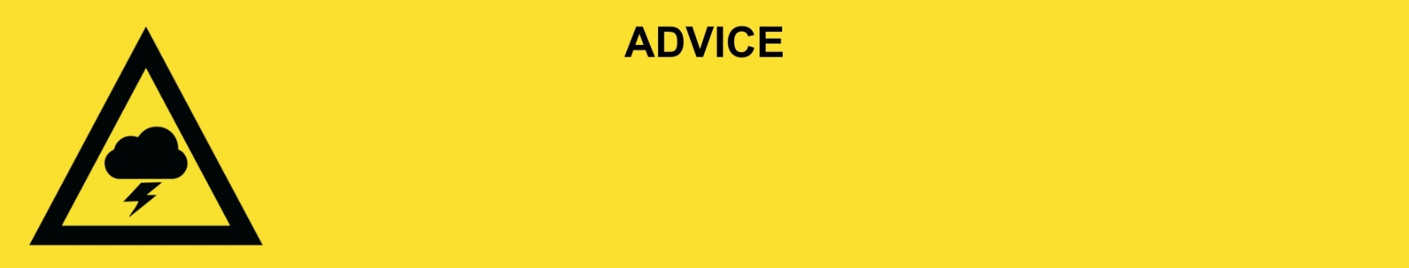
Issued: [time, day, date, year]
Next update: [time, day, date, year] or as the situation changes or This will be the last warning issued for this event.

[Insert issuing agency] advises that for people in the following location(s):
- [Add location(s) here]

the THREAT IS REDUCED. The severe weather has passed. You can now go outside but be careful of dangers and hazards left behind from the storm.

For non-life-threatening flood and storm emergency assistance, contact SES on 132500, 132500.qld.gov.au, or the SES Assistance Qld app on Android or iOS. In a life-threatening situation, call Triple Zero (000) immediately.

What we are expecting:
- There is significant damage in the area.
- Power and water are off in some places. These will be restored when it is safe.
- There may be fallen trees, branches, and debris on the roads.

What you should do:
- Stay away from creeks, rivers, and drains.
- Travel slowly, plan your route carefully to avoid any flooded or damaged roads and allow extra travel time. Damage to roads and buildings may still exist in your area.
- Be aware of road hazards including tree branches and debris.
- Check in on your neighbours, animals, and livestock if safe to do so.

If your property has been damaged:
- Make sure your property is safe before entering. Check for damage to windows, walls and the roof and be careful of potential dangers including asbestos.
- Make sure the electricity and gas are turned off before going inside.
- If power points, electrical equipment, appliances or electrical hot water systems have been exposed to water or are water damaged in any way, they must be inspected by a qualified electrician before use.
- Gas appliances and gas bottles that have been exposed to floodwater should be inspected for safety before use.
- Wear suitable protective clothing, including boots and gloves when cleaning up.

Support and recovery help:
- Go to [insert council name and website] for clean-up and recovery information.
- Recovery services are available [insert details of organisations actively involved; ideally on the ground]:
  - Agency – Location, full address and times.
- For general relief and recovery information go to the Get Ready Queensland website (After a Disaster).
- Natural disasters can affect your mental health. If you need help, call any of these groups:
- Lifeline: Go to lifeline.org.au or phone 13 11 14.
- Beyond Blue: Go to beyondblue.org.au or phone 1300 224 636.
- Kids Helpline: Go to kidshelpline.com.au or phone 1800 551 800.

For more information:
- Follow our local council disaster dashboard here [insert disaster dashboard link].
- Listen to your local radio [add ABC local radio or other station and frequency].
- For power outage information go to energex.com.au or ergon.com.au/network [select energy provider].
- Check the latest weather, warnings, rainfall, and river heights at the Bureau of Meteorology Queensland website.
- Check road closures at the QLD Traffic website or for phone service call 13 19 40.
- Check disruptions to public transport at the Translink website.

