AVOID THE AREA
[Location]
Tropical Cyclone [Name]
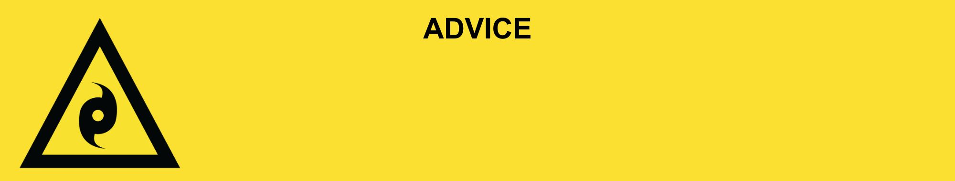
Issued: [time, day, date, year]
Next update: [time, day, date, year] or as the situation changes.

[Insert Issuing Agency] advises to AVOID THE AREA in the following area(s):
- [Add location(s) here]

Tropical Cyclone [Name] [has now passed / is currently passing / predicted to pass at TIME.] You still need to be careful of the dangers and possible damages of the cyclone.

For non-life-threatening flood and storm emergency assistance, contact SES on 132500, 132500.qld.gov.au, or the SES Assistance Qld app on Android or iOS. In a life-threatening situation, call Triple Zero (000) immediately.

What are we expecting?
- Powerlines and trees may have fallen. They can be hard to see when covered in debris.
- The power and phone services [might be / has been] impacted. They will be restored when staff and supplies can get through, and when safe.
- Roads [are / may be] closed or badly damaged.
- Water supply [might be / has been] impacted. Drink only water from your emergency supply.
- There could be [crocodiles, sharks, snakes] or raw sewerage.
- Heat and humidity often follow tropical cyclones.

What you need to do:
- Avoid returning to homes or businesses due to [damage / possible damage.] If you choose to return, drive slowly and remain alert. Be aware of fallen powerlines, trees, and other hazards.
- Power is off in some places. These will be restored when it is safe.
- Do not go sight-seeing. Keep roads clear for emergency services.

Support and recovery help:
- Go to [insert council name and website] for clean-up and recovery information.
- Recovery services are available [insert details of organisations actively involved; ideally on the ground]:
  - Agency – Location, full address and times.
- For general relief and recovery information go to the Get Ready Queensland website (After a Disaster).
- Natural disasters can affect your mental health. If you need help, call any of these groups:
  - Lifeline: Go to lifeline.org.au or phone 13 11 14.
  - Beyond Blue: Go to beyondblue.org.au or phone 1300 224 636.
  - Kids Helpline: Go to kidshelpline.com.au or phone 1800 551 800.

For more information:
- Follow our local council disaster dashboard here [insert disaster dashboard link].
- Listen to your local radio [add ABC local radio or other station and frequency].
- For power outage information go to energex.com.au or ergon.com.au/network [select energy provider].
- Check the latest weather, warnings, rainfall, and river heights at the Bureau of Meteorology Queensland website.
- Check road closures at the QLD Traffic website or for phone service call 13 19 40.
- Check disruptions to public transport at the Translink website.

