TOO DANGEROUS TO LEAVE
[Location]
Flood (Descriptor)
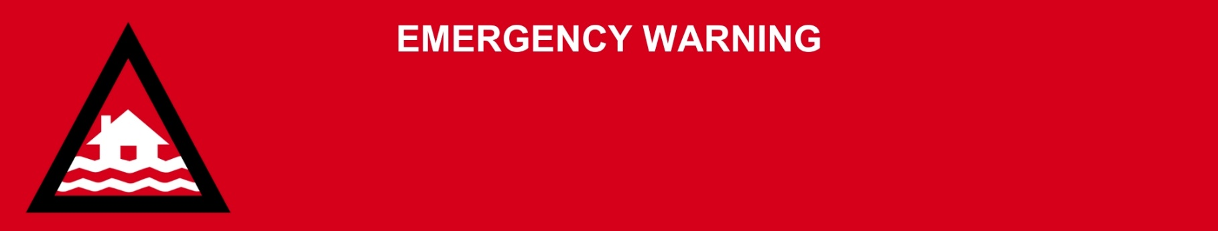
Issued: [time, day, date, year]
Next update: [time, day, date, year] or as the situation changes

[Insert issuing agency] advises the people in the following area(s):
- [Add location(s) here]

Must stay in place, it is TOO DANGEROUS TO LEAVE.

Get up as high as you can where you are. There is [dangerous, major, wide-spread, fast-moving and/or unpredictable] flooding. Evacuation routes are now cut off by flooding. Your life is at risk.

If your life is in danger, call Triple Zero (000) immediately.
Emergency services may not be able get to you because it is too dangerous.

What are we expecting?
The Bureau of Meteorology advises [insert BOM prediction here, including time/when it’s expected to hit].
- Homes and buildings are [badly / fully] flooded.
- Main roads are closed.
- Evacuation routes are closed.
- Power, phones, internet, and water [might stop working / have stopped working].

What you need to do:
- Stay where you are and get up as high as you safely can. This could be upstairs or on the roof if it is safe to do so.
- If you have children make sure they are with you or an adult you trust.
- Help other people who are with you if you can.
- Stay in place until you are rescued, or the water goes down enough to safely leave.

For more information:
- Follow our local council disaster dashboard here [insert disaster dashboard link].
- Listen to your local radio [add ABC local radio or other station and frequency].
- For power outage information go to energex.com.au or ergon.com.au/network [select energy provider].
- Check the latest weather, warnings, rainfall, and river heights at the Bureau of Meteorology Queensland website.
- For non-life-threatening flood and storm emergency assistance, contact SES on 132500, 132500.qld.gov.au, or the SES Assistance Qld app on Android or iOS.
- Check road closures at the QLD Traffic website or for phone service call 13 19 40.
- Check disruptions to public transport at the Translink website.

