AVOID THE AREA
[Location]
Severe Weather (Descriptor)
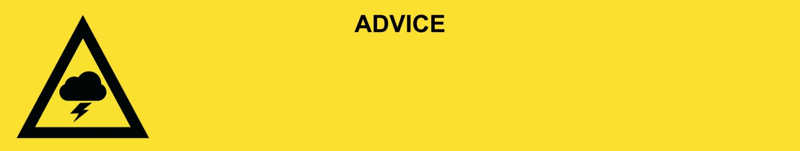
Issued: [time, day, date, year]
Next update: [time, day, date, year] or as the situation changes or This will be the last warning issued for this event.

[Insert issuing agency] advises that the people in the following location(s):
- [Add location(s) here]

to AVOID THE AREA in the following location(s) due to [significant damage / fallen power lines / damaged buildings].

For non-life-threatening flood and storm emergency assistance, contact SES on 132500, 132500.qld.gov.au, or the SES Assistance Qld app on Android or iOS. In a life-threatening situation, call Triple Zero (000) immediately.

What we are expecting:
- The [storm/thunderstorm/severe weather] has passed but there is [extensive, significant, a lot] of damage.
- People to avoid the area. This will keep roads clear for emergency vehicles.
- If you are already in the area, stay inside if possible.

What you need to do:
- It might not be safe to start cleaning up yet. Check for hazards before you enter a damaged building or area.
- Stay away from fallen powerlines. These can be hard to see.
- Check on neighbours if it is safe to do so.
- Avoid places damaged by the storm.
- Floodwater is dangerous - never drive, walk, play, or ride through floodwater.
- Stay away from storm water drains.
- Some places do not have clean water. Tap water is not safe to drink.

Support and recovery help
- Go to [insert council name and website] for clean-up and recovery information.
- Recovery services are available [insert details of organisations actively involved; ideally on the ground]:
  - Agency – Location, full address and times.
  - Agency – Location, full address and times.
- For general relief and recovery information go to the Get Ready Queensland website (After a Disaster).
- For more information relating to your local council area, refer to your local council disaster dashboard here - [insert disaster dashboard link here]
- Natural disasters can affect your mental health. If you need help, call any of these groups:
- Lifeline: Go to lifeline.org.au or phone 13 11 14.
- Beyond Blue: Go to beyondblue.org.au or phone 1300 224 636.
- Kids Helpline: Go to kidshelpline.com.au or phone 1800 551 800.

For more information:
- Follow our local council disaster dashboard here [insert disaster dashboard link].
- Listen to your local radio [add ABC local radio or other station and frequency].
- For power outage information go to energex.com.au or ergon.com.au/network [select energy provider].
- Check the latest weather, warnings, rainfall, and river heights at the Bureau of Meteorology Queensland website.
- Check road closures at the QLD Traffic website or for phone service call 13 19 40.
- Check disruptions to public transport at the Translink website.

