AVOID THE AREA
[Location]
Flood (Descriptor)
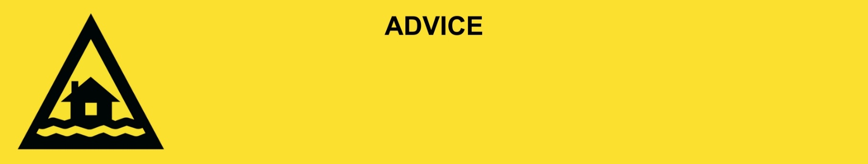
Issued: [time, day, date, year]
This will be the last warning issued for this flood in [location].

[Insert Issuing Agency] advises that people from the following area(s):
- [Add location(s) here]

should AVOID THE AREA. You should avoid the area the area as flood damage can be widespread.

What we are expecting:
- Roads and buildings have been badly damaged.
- Power and water are off in some places. These will be restored when it is safe.
- There is a lot of mud and rubbish on the ground and in the water.
- There could be more snakes, spiders, and rats inside.

What you need to do:
- Stay away from creeks, rivers, and drains.
- Drive slowly, plan your route carefully to avoid any flooded roads and allow extra travel time.
- Never drive, walk, ride, play or swim in flood water. If it’s flooded, forget it.
- Be aware of road hazards including mud and debris.
- Check in on your neighbours, animals, and livestock if safe to do so.
- Stay away from the area unless you live or work there, or you are helping.

Support and recovery help:
- For non-life-threatening flood and storm emergency assistance, contact SES on 132500, 132500.qld.gov.au, or the SES Assistance Qld app on Android or iOS.
- Go to [insert council name and website] for clean-up and recovery information.
- Recovery services are available [insert details of organisations actively involved; ideally on the ground]:
  - Agency – Location, full address and times.
- For general relief and recovery information go to the Get Ready Queensland website (After a Disaster).
- Natural disasters can affect your mental health. If you need help, call any of these groups:
  - Lifeline: Go to lifeline.org.au or phone 13 11 14.
  - Beyond Blue: Go to beyondblue.org.au or phone 1300 224 636.
  - Kids Helpline: Go to kidshelpline.com.au or phone 1800 551 800.

For more information:
- Follow our local council disaster dashboard here [insert disaster dashboard link].
- Listen to your local radio [add ABC local radio or other station and frequency].
- For power outage information go to energex.com.au or ergon.com.au/network [select energy provider].
- Check the latest weather, warnings, rainfall, and river heights at the Bureau of Meteorology Queensland website.
- Check road closures at the QLD Traffic website or for phone service call 13 19 40.
- Check disruptions to public transport at the Translink website.

