PREPARE NOW
[Location]
Severe Weather (Descriptor)
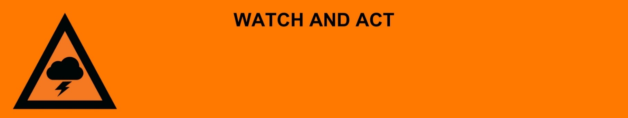
Issued: [time, day, date, year]
Next update: [time, day, date, year] or as the situation changes.

[Insert issuing agency] advises people in the following area(s):
- [Add location(s) here]

to PREPARE NOW due to a [dangerous/severe] [dust storm/thunderstorm/severe weather] that is [approaching now/approaching very soon].

For non-life-threatening flood and storm emergency assistance, contact SES on 132500, 132500.qld.gov.au, or the SES Assistance Qld app on Android or iOS. In a life-threatening situation, call Triple Zero (000) immediately.

What are we expecting?
The Bureau of Meteorology advises [insert BOM prediction here, including time/when it’s expected to hit].
- Damaging hail.
- Very heavy rain making it dangerous to drive, flash flooding is possible.
- Dust storms with the potential to cause respiratory issues.
- Strong winds causing debris like fallen trees, powerlines could come down and the power could go out.

What you need to do:
- Find out how to get ready for severe weather at the Get Ready Queensland website (Get Prepared).
- Close doors and windows and move or stay indoors clear of windows.
- If you must travel, consider the consequences of road conditions and closures, and make alternate arrangements for work, children, and travel.
- Pack away, tie down, or secure outdoor furniture, toys, and trampolines.
- If your roof or house is struck by a fallen tree/branch or other large debris - stay clear and remain indoors if you can. It may have been structurally weakened, even if there is no obvious damage.
- Put your pets somewhere safe, ensure they can be easily identified if they get lost.
- Keep medications close by.
- Charge mobile phones and power banks in case power goes out.
- Locate your emergency kit in case you lose power.
- If caught outdoors, shelter under sturdy cover away from trees, and power lines.
- Stay clear of fallen trees, power lines and damaged buildings.
- Do not drive in floodwater. If you come to a flooded road turn around and go another way. Turn your headlights during severe weather.
- Warn friends, family, and neighbors in the area.

If you decide to leave early:
- Lift important things onto bed, tables, shelves or upstairs to protect them.
- Lift waste containers, chemicals, and poisons up high.
- Pack enough clothes, food, water, medicine, baby items (like nappies, formula) and pet food for [three / five / other] days. Plan not to have a fridge or microwave.
- Take your pets, mobile phone charger, battery-powered radio, torch, and valuables like photos, cash, and important documents (like identification, insurance, or banking records).
- Lock windows and doors.
- Go to a safe place, away from severe weather. This could be with family or a friend.
- If you come to a flooded road, turn around and go another way. Do not drive through floodwater.

If you find it hard to move quickly or have special or medical needs:
- Use your Person-Centred Emergency Plan (P-CEP) now if you have one.
- Make sure you have enough medicine for at least one week.
- If anyone in your house uses powered medical equipment, like a dialysis machine or ventilator, decide now where you will go in case you lose power.
- Call your support person or service to organise transport if you need to leave.
- Leaving early is safer than waiting.

If you are a tourist, visitor, camper or caravanner:
- Campers and caravanners should consider packing up now.
- If you do not need to be in the warning area, leave now. Check road conditions and plan your route before you leave.
- Be ready to move if the situation gets worse.
- Ask the campground owners whether the site floods.
- Check your surroundings of water catchments, and monitor conditions.

For more information:
- Follow our local council disaster dashboard here [insert disaster dashboard link].
- Listen to your local radio [add ABC local radio or other station and frequency].
- For power outage information go to energex.com.au or ergon.com.au/network [select energy provider].
- Check the latest weather, warnings, rainfall, and river heights at the Bureau of Meteorology Queensland website.
- Check road closures at the QLD Traffic website or for phone service call 13 19 40.
- Check disruptions to public transport at the Translink website.

